Computer Language Coding Concepts

System Interfaces of Objects and References
There are system commands that apply to Objects and system commands that apply to References, but when you show the system interface of a symbol, which do you show? The system interface of the Object or the system interface of the Reference?

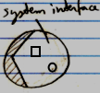

The solution for this problem is that you always deal with references to objects, never with the object directly, so when you open up the system interface of a symbol, the system interface of the Reference is shown. However, inside of it you will find the referenced Object, showing its system interface.

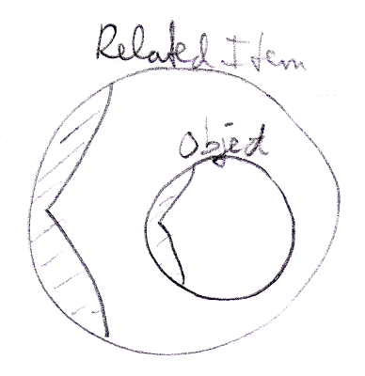

Author & Copyright: Jan-Joost van Zon Date: August 27, 2009 – August 27, 2009 Location: Oosterhout, The Netherlands Status: Finished

